**Client Interface Report**

**Introduction:**

The first step in developing an application is the development of a client interface. A client interface is a way through which a user can interact with the application and the application performs functions as requested by the user through client interface. As we are developing an application which provides various services, user must be able to select a particular service he wants and the application should return the result as requested by the user. I implemented this by using a form inputs and depending upon what input is selected the application is going to return the result accordingly. I made the client interface by using html, css and javascript language. Html to make the webpage, css to design the webpage and javascript to add functionality to the webpage.

**UML Diagram:**

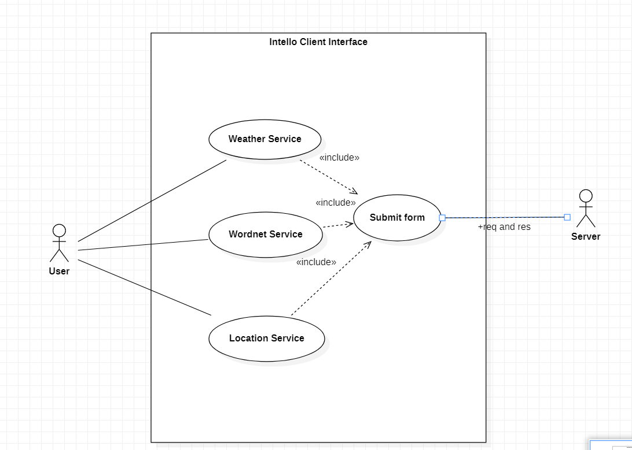

The use case diagram shown above represents how user will interact with the application, we have not made any server yet ,so user can only select the type of service and click submit to submit his request, whether its weather service or wordnet service or location service. The submit button will post the form data to server when clicked and the server will send response with the required data.

**Evaluation and Design:**

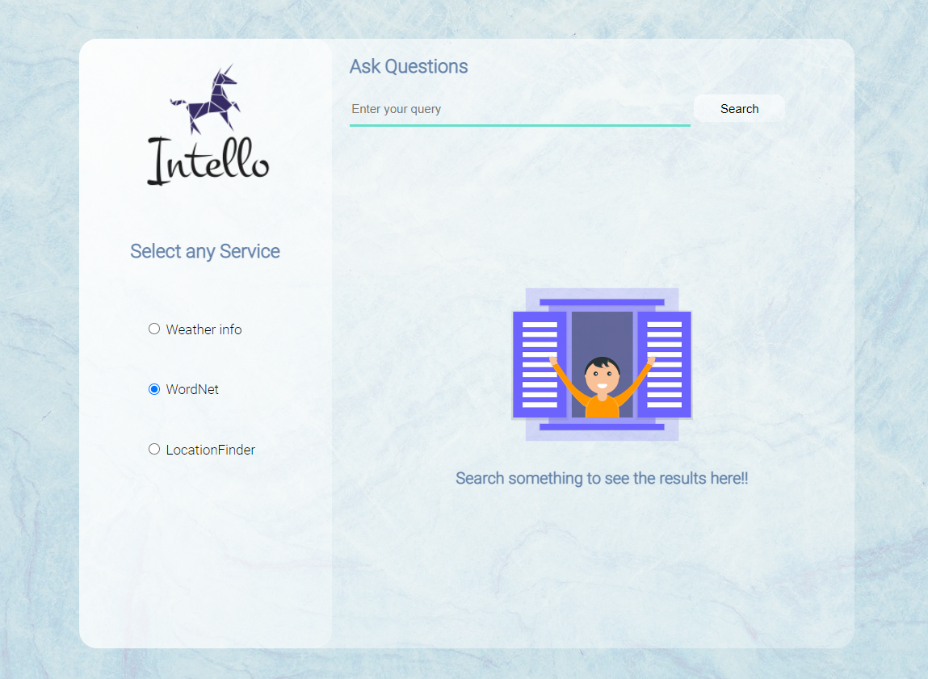

Above picture shows the design of client interface. It’s a simple design where the data will be displayed on the right hand side and the user will select different services from the options available on the left hand side.

Developing this application was a great learning experience as I learned a lot of new things about development as I progressed further in the development. I learned about flexbox, which I used in css to align the different elements in the webpage.

**Client and server interaction:**

The server upon receiving the client post request determine what type of service is requested by the client and depending upon that it will redirect the request to its particular service handler function. The service handler function will make an API call to the particular service API and extract the data from its response. At the end , the server will send the required data back to the client which will be rendered on the client interface.

**References:**

Design inspiration: <https://twitter.com/developedbyed>

Background Image from: <https://www.pexels.com/search/abstract/>

Illustration from: <https://undraw.co/illustrations>

Logo : <https://www.freelogodesign.org/>